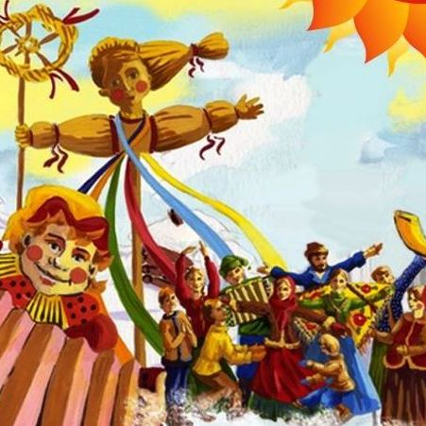
Russian Maslenitsa
Maslenitsa or Pancake Week is a traditional Russian festival before Lent.
So, how do Russian celebrate it? First, they make and eat lots of pancakes. People usually eat them with sour cream and with some filling. The filling can be different: meat, fish or jam.
Pancake Week is a very jolly and happy time. People arrange street festivals with traditional Russian amusements. They led dances, play snowballs, ride roller coaster and horses. Each day of Maslenitsa has its own name: greeting, sweet-tooth, revelry and farewell. On Sunday (the last day of this holiday) people ask for forgiveness to each other.
Vocabulary:
festival = holiday
Great Lent- Великий Пост
to celebrate - праздновать
filling- начинка
amusement- забава, развлечение
to led dances – водить хороводы
to ride roller coaster – кататься с горки
Days of Maslenitsa: - Дни Масленицы
greeting- встреча
sweet-tooth- лакомка
revelry- разгул
farewell- проводы
to ask for forgiveness-просить прощение

